Course: CSE 204 – Computer Networks
LAB 10 – Review
Due date: June 18th, 2025

Student name | Nguyen Xuan Huan
Student ID | 2131200077

Objective
- Implementing VLAN and VLAN Trunking
- Implementing DHCP
- Implementing Static Routing and Dynamic Routing
- Implementing Access Control List
- Implementing Static NAT and Dynamic NAT

Assignment list
II.1. Implementing VLAN and VLAN Trunking
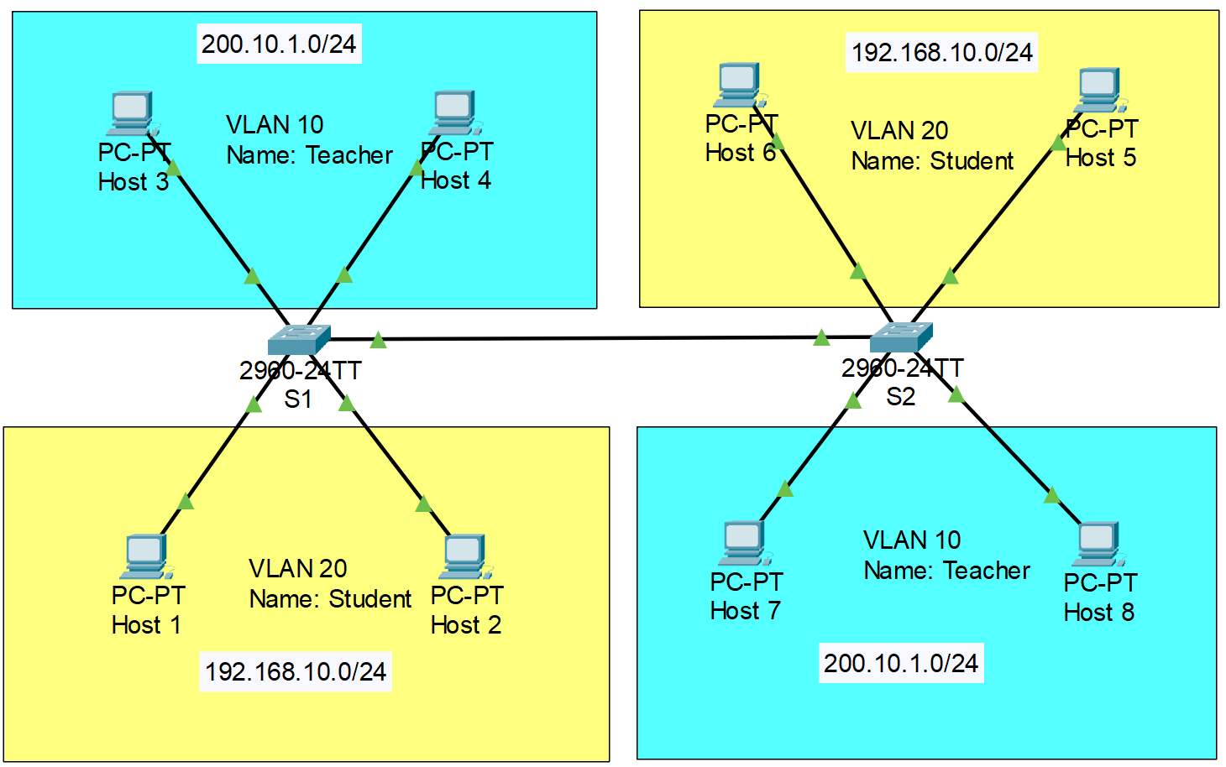
- Note: VLAN 10: port 3, 4. VLAN 20: port 10, 11. Trunk: port 1
- Configure VLAN as shown in the figure above. Then, implement VLAN Trunking on 2 Switches, so that 2 PCs in the same VLAN, but different Switches can ping each other.
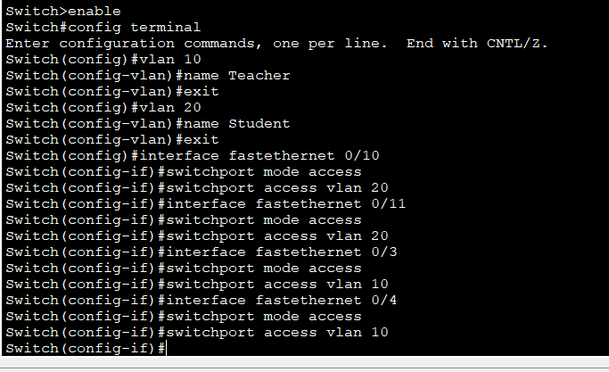
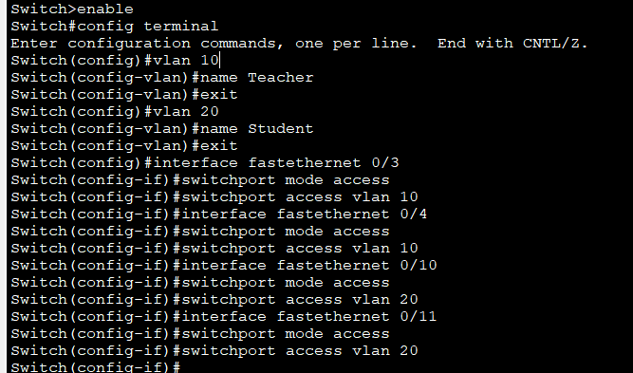
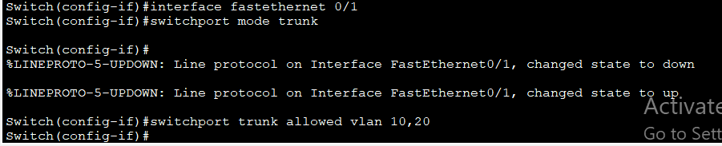
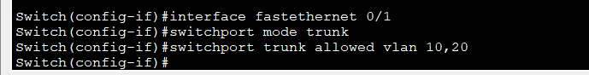
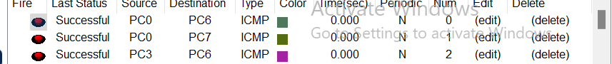
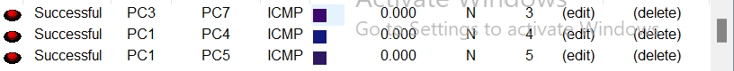
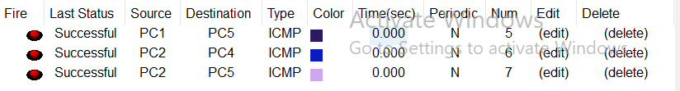
II.2. Implementing DHCP
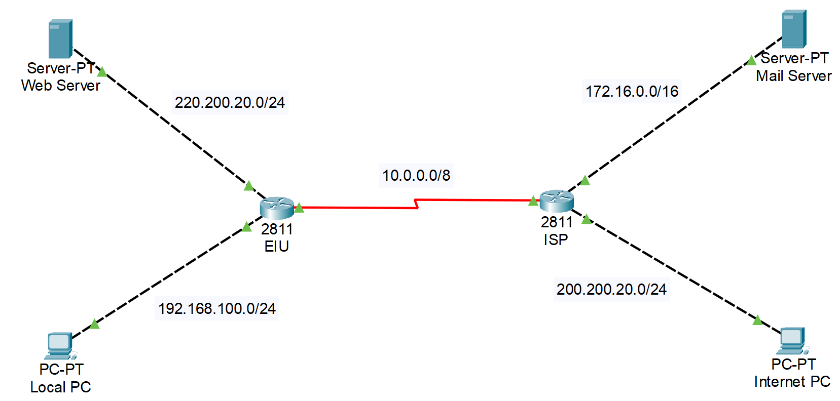
- Configure DHCP in each router based on the given information in the figure above. Result of each steps:
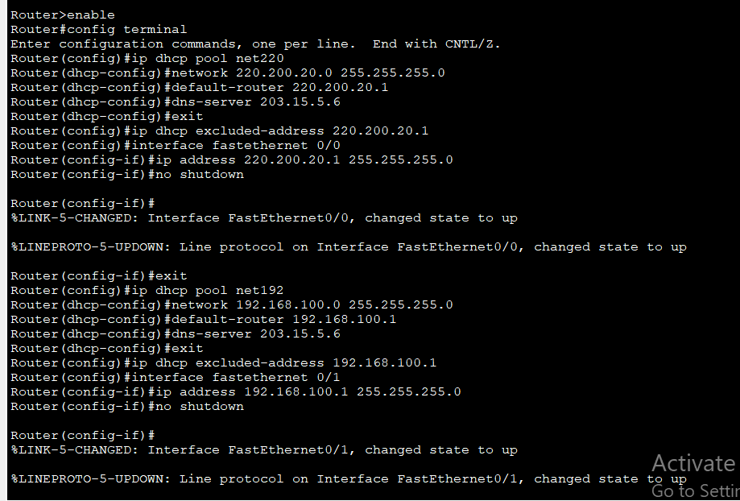
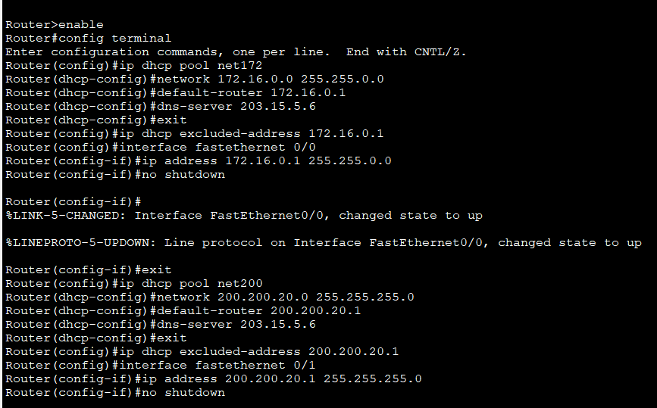
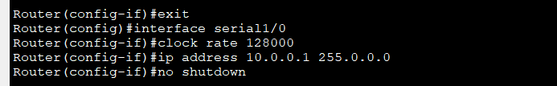
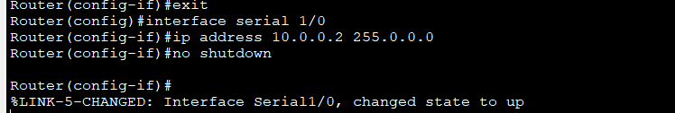
II.3. Implementing Static Routing and Dynamic Routing
Note: Please use 2 different models to configure static and dynamic routing.

- Configure DHCP in each router based on the given information in the figure above. Then configure static routing and dynamic routing so that all of the devices can ping to each other. Show the results of each steps:
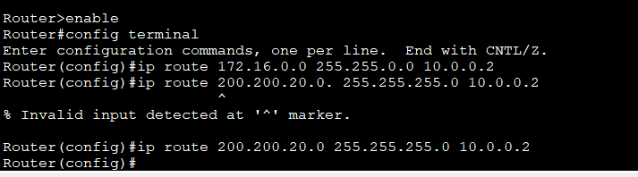
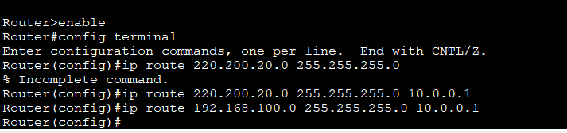
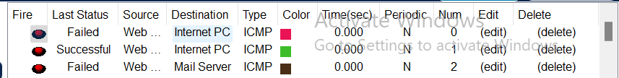
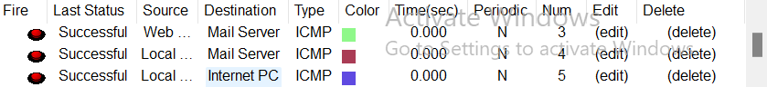
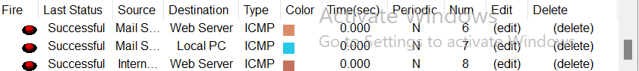
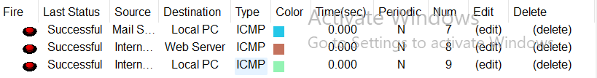
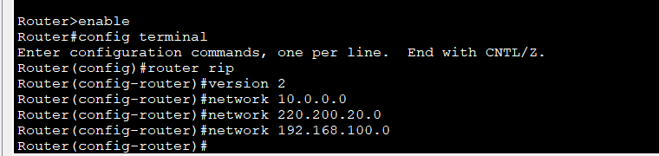
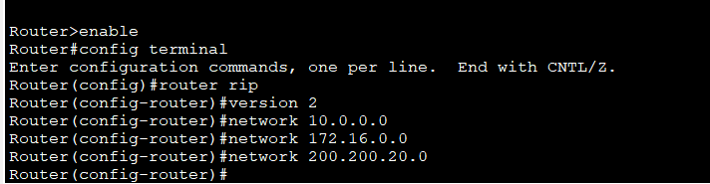

II.4. Implementing Access Control List (ACL)
- Config IP address using DHCP to all Routers, PCs and routing protocols, so that all of them can ping to each other. Show the results of each step:

- Configure Access Control List on the Router EIU to make: ONLY Local PC cannot ping to Mail Server. Show the results:
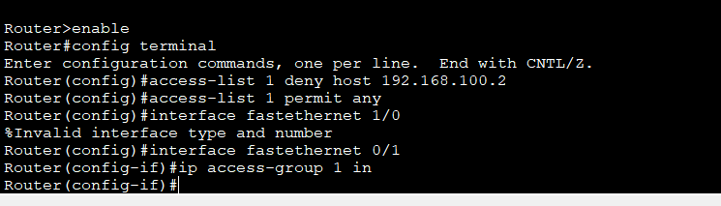
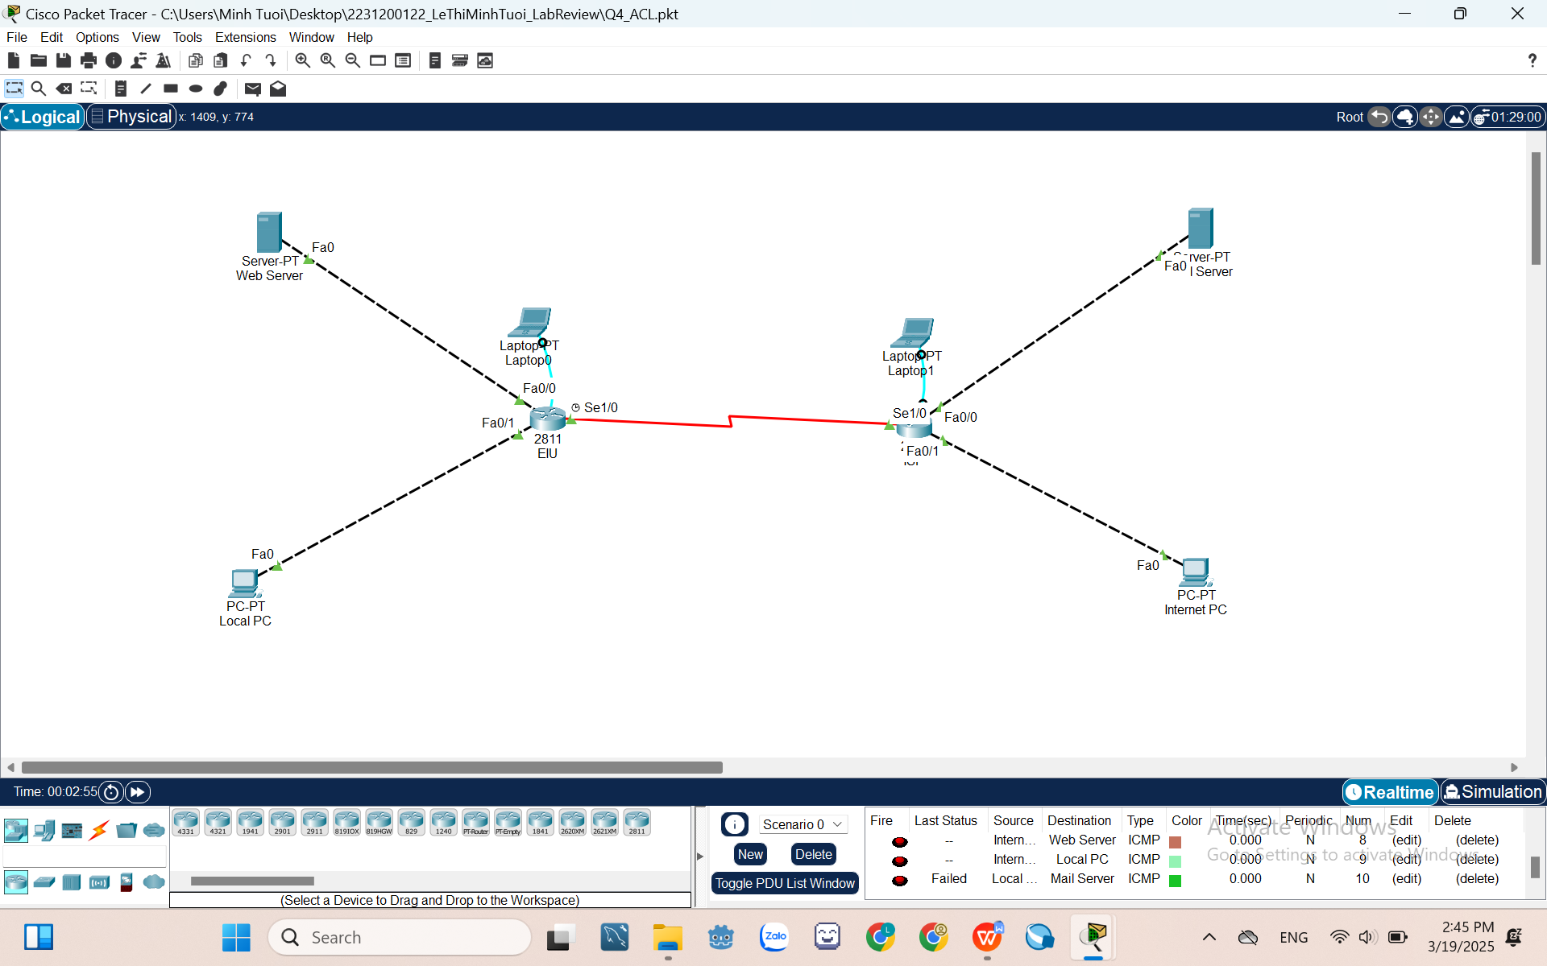
II.5. Implementing Static NAT and Dynamic NAT
- Configure DHCP in each router based on the given information in the figure above.
Note: Please use 2 different models to configure static and dynamic NAT.

- Static NAT
- Assume that Router EIU can use the IP address range 199.99.9.3/24. Using Static NAT at Router EIU to translate IP address of Web Server to public IP address. If configure successfully, Web Server can ping to Internet PC and Mail Server.
- Result of each steps:
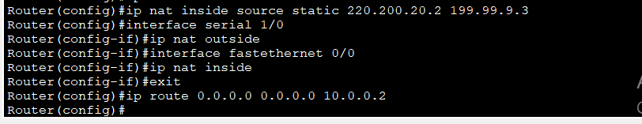
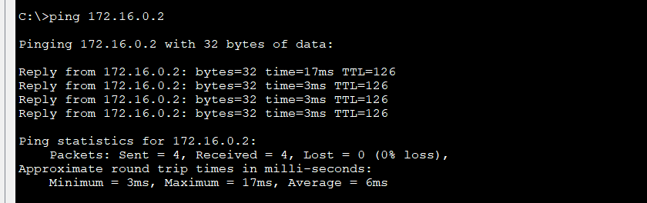
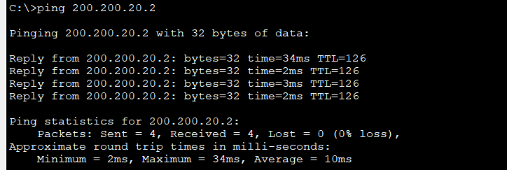
- Dynamic NAT
- Assume that Router EIU can use the IP address range MyPool 199.99.9.33 to 199.99.9.62/27). Using Dynamic NAT at Router EIU to translate local IP address of Web Server to MyPool. If configure successfully, Web Server can ping to Internet PC and Mail Server.
- Result of each steps:
